**Edge Detection**

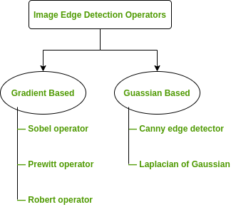

**Image Segmentation**

* Partitioning an image into meaningful regions with respect to a particular application.
* Simple segmentation is based on measurements taken from the image and might be based on brightness (grey-level), colour, texture, motion, etc.

**Image Segmentation Techniques**

|  |  |
| --- | --- |
| **Regions** | **Boundaries** |
| Pixel-by-pixel  (global statistics)  Thresholding | Image Gradient  (energy driven)  Active Contours |
| Groups of Pixels  (similarity)  Clustering  Region Growing  Relaxation | Model Based  (statistics of shape)  Active shape model |

Image Segmentation can be classified as:

* Non-automated
  + Identifying regions by hand!
* Semi-automated
  + Thresholding
  + Region Growing
  + Active Contour, etc.
* Automated
  + Model based  
     • Area of intensive research

**Thresholding**

Classifying pixels as belonging to the “objects” or “background” depending on their value. T is called ‘Threshold value’.

But how to select the threshold value?

Possible approaches:

* Interactive threshold (manually setting threshold values)
* Adaptive threshold
* Variance minimisation method (Otsu threshold selection algorithm)

**Advanced segmentation methods**

* Active contours (snakes)
* Watershed